**Measuring IT Performance and Communicating Value**

**Article #5 Review**

**BUS ADM 744 – Information Technology Strategy & Management**

**10/9/17**

Team Voldemort

Priyanka Lakshmi Vakkalanka

Michael Carpenter

Xinyu Zhao

SibelIbryamova

Robert Baitinger

# **Summary**

Topic and Motivation

IT has begun to play a major role in business performance. CEO’s and executive teams are not only interested in IT operating metrics. CIO’s want to demonstrate how IT can help in business transformation by increasing the performance and motivation of employees, rather than showing performance metrics like server uptime, support system statistics and project report updates. New ways and methods to measure the performance are to be developed and implemented as the role of the CIOtransforms from a traditional support player to an active and fundamental partner in the success of the business. It is difficult to allocate the resources accurately without a complete representation of the impact IT has on Business; because of this, resources that IT provides have become more vital to the Business’s product. IT needs adequate resources to be able to help the Business realize its potential. To ensure that IT is valued appropriately, the CIO needs to put the IT department's performance in terms of its overall impact on the individual lines of Business. Mitra, Sambamurthy and Westerman sought to quantity the current metrics in use and theorize on their role in determining business success in the future.

Research Question

The article authors sought to answer the two following questions: What are the major metrics currently in use for measuring IT performance, and what are recommendations for improving IT Performance/Value in areas of desired focus?

The main dilemma CIO’s are facing is this: as the role of CIO continues to change and is transformed from support staff to strategic partner, it is difficult to answer these two questions. The fundamental gap between IT execution that be measured and the value from IT that can be communicated makes these types of questions hard to answer as well. (Mitra, Sambamurthy, &Westerman, 2011) Hence in today’s time, it is of utmost importance that the CIO’s keep themselves continuously updated about the new technologies that are emerging and also should be able to switch from an old technology to new a new one without losing efficiency.

Approach

Researchers used interviews with CIO’s from organizations in many different industries. The Appendix at the end of the article breaks down the representation as such:

Financial Services - 4

Insurance - 4

Retail - 3

Software - 2

E-commerce - 2

Non-Profit - 2

Telecommunications and Electronic Manufacturing - 2

Chemical - 1

Automotive - 1

Entertainment - 1

Pharmaceutical – 1

The interviews were conducted in a structured format, but used open-ended questions that were not leading, which helped the researchers avoid confirmation bias. It also allowed for the interviewees to bring up points, methods, and metrics that the authors were not aware of or had not originally considered.

The interviews were structured to start very generally by getting an overall sense of the role of IT in the organization. Then the researchers looked into how the IT functions, how CIOs are evaluated by the other members of the board, and how the CIO communicates the value of his role with them. They also looked at how IT function was evaluated internally. For both lines of questioning the metrics used in the evaluation were a huge focus. They wrapped up the interview by evaluating the company’s current use of metrics and how that evolved over the previous 5 years as well as any personal lessons the individual had learned in using these metrics during that period.

The authors used previous interviews on related subjects as well, but the 23 performed specifically for this article provided the best insight for the ‘Metrics Portfolio’.

Conclusions

Basically, this article is talking about how to better measure the IT performance and Value and enable CIOs to develop an effective strategy for managing and communicating metrics for IT performance. To do so, we must know what IT value actually is. According to the article, “IT value is measured by performance metrics on dimensions that stakeholders find important.”

The article defines a tool called “portfolio of metrics”. CIOs can use the portfolio to clarify performance responsibilities and identify focal metrics for improvement. In this case, depending on the need of CIO and stakeholder, this portfolio can be a good resource for CIO to come up with effective strategy. The breakdown of the portfolio is as follows:

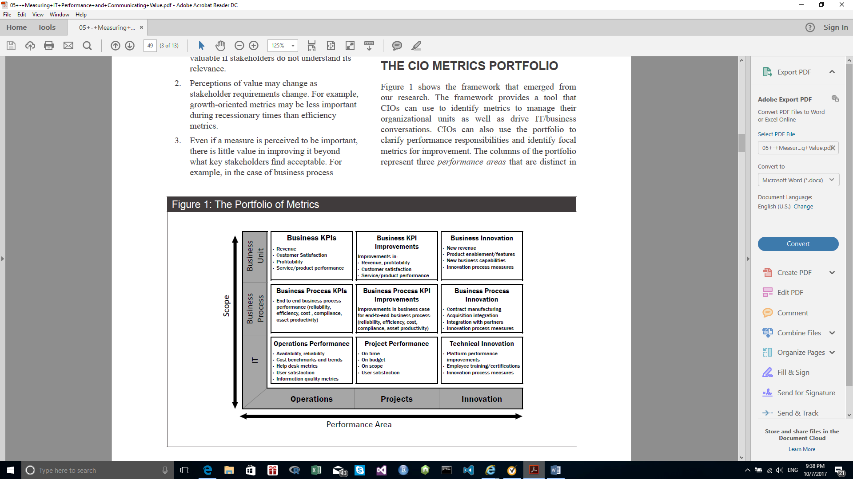

### Performance Areas -- columns of the portfolio

*Operations* metrics capture the performance of existing infrastructure and business processes.

*Project* metrics capture the successful execution of change activities.

*Innovation* metrics describe the enterprise’s ability to pursue potentially valuable opportunities that it would not pursue through its traditional activities.

### Scopes – rows in the portfolio

*IT* metrics describe technology service performance.

*Business process* metrics focus on the performance of business processes, such as business process efficiency and quality.

*Business unit* metrics focus on overall business or business unit performance, as exhibited by financial and customer-facing measures.

Mitra, Sambamurthy, and Westerman identified five distinct combinations of metrics that the CIOs in their study used to measure and communicate IT performance and value. These five specific focus domains are:

*Internal IT Focus*: The CIO’s focus is on IT-specific outcomes.

*Project Focus*: The CIO’s focus is on effective delivery of projects and their business benefits.

*Business Operations Focus*: The CIO’s focus is on reliability and efficiency of current business operations.

*Business Process Focus*: The CIO’s focus is on improving performance, either at the process or the overall business level.

*Innovation Focus:* The CIO’s focus is on the enablement of business innovation.

Even if there are five major domains on which CIOs focus regularly, that doesn’t mean this metric can only be used for these purposes. This metric can be used for different purposes based on the need of CIO and stakeholder, like planning, communicating, reporting, and performance monitoring, and even changing stakeholder behavior.

# **Lessons**

Guiding Principles

The portfolio of metrics is a metrics identification framework that emerged from the research presented in this article. It serves as a useful guide for selecting metrics and focus domains. The framework provides a tool that CIOs can use to identify metrics to manage their organizational units and drive IT value conversations with business executives. It can also be used to clarify performance responsibilities and identify essential metrics for improvement. CIOs can take charge of the value conversation by building a portfolio of metrics that matter to key stakeholders, improving IT performance along these key metrics, and then adjusting the portfolio of metrics over time.

The columns of the portfolio represent three performance areas that are managed and evaluated differently – operations, projects, and innovation. Each of the rows of the portfolio represents metric scope – IT, business process, and business unit.

According to the article, firms expect from their CIOs effective performance in the areas of IT-specific operations and IT-specific projects. However, communication solely on these dimensions results in the perception that the CIO’s impact on the business is very limited since the associated metrics measure technical performance, and they are difficult to measure consistently as business value. CIOs with a higher impact on the business can move the value conversation beyond these two IT-specific performance areas.

The article identifies the five practices that CIOs use to shift the conversation with business executives to business value and higher levels of strategic impact.

### Being proactive in defining metrics

To be able to focus on dimensions that are business-relevant, CIOs should define how different performance dimensions link to value in the eyes of stakeholders. They need to determine the metrics that matter in each cell of the portfolio of metrics for each business process or business unit. They also need to identify the owners of those metrics and determine how IT can help to improve each metric. Being proactive in defining metrics allows the CIO to lead the IT value conversation and formulate the change agenda. As a result, IT performance will be improved and the CIO will have a stronger strategic role.

### Discussing IT unit performance in business terms

Describing IT unit performance in business terms — for example, presenting IT service metrics in terms of their impact on unit costs and demand levels, or IT availability in terms of business process reliability —helps business executives understand the business value of IT activities and enables more clear communication between the two sides. CIOs increase their credibility by acknowledging performance issues and showing improvement. They can use metrics to make the case for additional investments in areas where improvements are needed. Additionally, discussing IT metrics in business terms with IT staff helps them see their impact more clearly, resulting in performance improvements due to increased pride and customer focus.

### Improving partnership by helping others improve their own areas

Metrics do not substitute for non-quantifiable measures such as trust and partnership, but they are critical to enhancing IT/business relationships since a discussion around metrics and performance helps to clarify potential decisions. Asking business unit executives what metrics matter to their annual compensation schemes and helping them improve those metrics is a powerful way to improve relationships. The result is engagement of business colleagues in joint efforts towards value creation from IT investments.

### Exercising influence beyond your scope of authority

CIOs can improve the contribution of IT to business value by ensuring business executives take responsibility for the realization of business benefits associated with completed IT projects. For example, the CFO and CIO can work together and hold each other accountable, with the CFO acting as the arbiter of value. IT values should not be separated from business value, but seen as parts of a joint effort towards improving business performance

### Focusing on a few strategically important improvement areas when communicating with senior executives

CIOs can best communicate their performance if they have a clear and focused story. Once performance in a central area reaches acceptable levels, CIOs can shift their focus upward and rightward in the metrics matrix to more strategic cells. When shifting focus, the areas with acceptable performance levels that are no longer of primary importance should be delegated to competent IT leaders and managed by exception. Negative performance in these non-central areas can quickly reverse a CIO’s strategic progress.

Predictions

It is important to realize that as the role of CIO continues to move towards business partner and one of enterprise stakeholder, so do the metrics and measures used to evaluate the contributions of the IT group they oversee. It is with this continued change that we will likely see more universal and stakeholder-friendly metrics used to make IT value and its estimation more accessible to individuals across the company. We will see IT contributions and expectations continue to increase in weight as accountability also increases in prevalence.

# **Questions**

1. What specific metrics do you think are most effective in monitoring the performance of the IT function?
2. What specific metrics do you think are most effective in communicating the value provided by the IT function?
3. Can you give an example of metric you use or have experience with in your current or previously help position? Where might that metric fall in the portfolio?

# **References**

Mitra, Sabyasachi; Sambamurthy, V.; Westerman, George. “*Measuring IT Performance and Communicating Value*”; MIS Quarterly Executive Vol. 10 No. 1; Mar 2011.